**Working with a Atudent with Social, Emotional   
and Behavioural Difficulties**

**Online Course Guidelines**

Tools and resources

**TOOLS FOR MANAGEMENT AND ADMINISTRATION OF THE COURSE**

# Budget calculation

A Course Budget Calculation Template (Annex 1 - excel sheet with the title Course-Budget-Template) should be used to calculate the expected cost of the training programme.

This template shows a course budget overview at the top, with itemized details of expenses and incomings below. You can use this worksheet to outline expenses, create a tentative budget, and compare actual costs as they accrue.

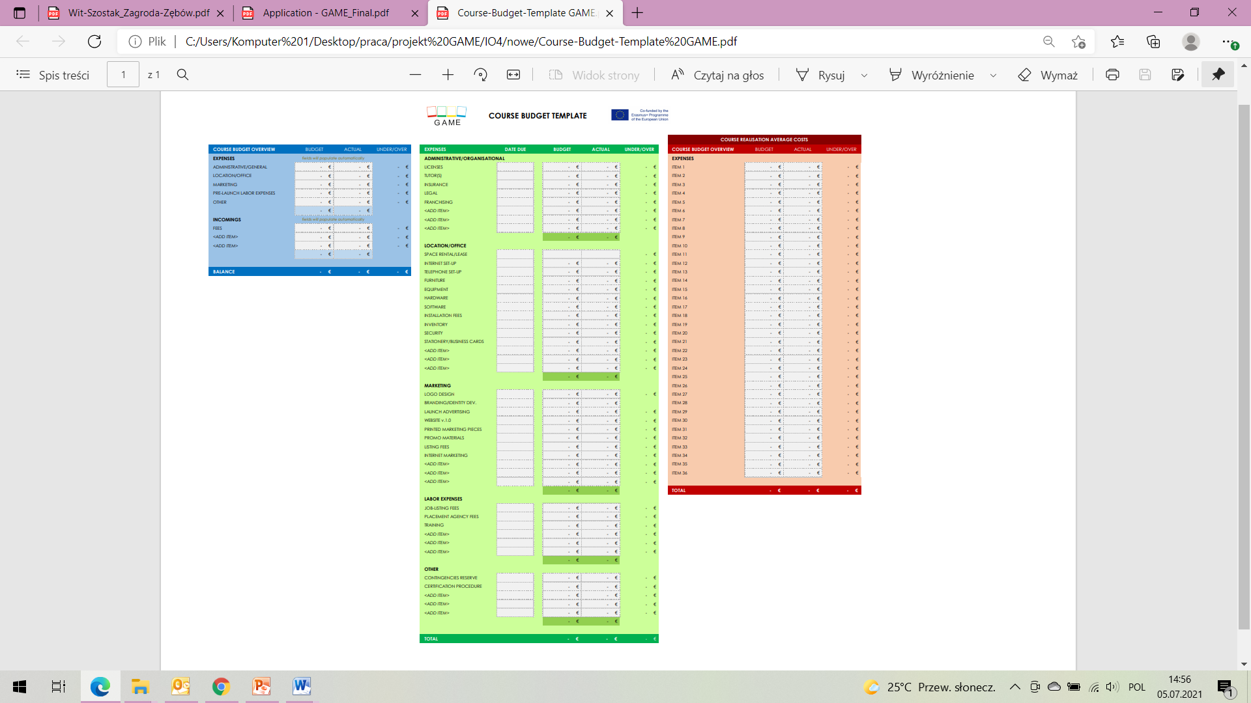

# Checklist

Checklist for the organisation and administration of training events/workshops template (Annex 2 – excel sheet with the title Course-Checklist-Template GAME) offers a simple checklist to help you organize all the tasks that need to be accomplished, from preparation, training and after training issues. You can adapt the list according your requirements and actions for a training/event workshop.

# 

# Course Planner Schedule

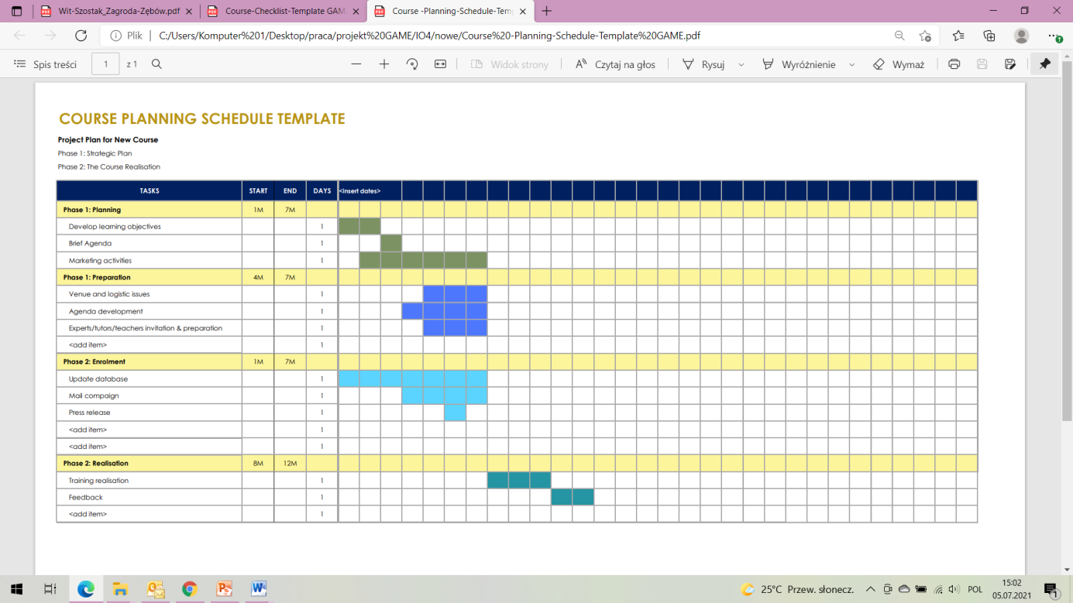Course planning schedule of training events/workshops – the form (Annex 3 - excel sheet with the title Course-Planning-Schedule-Template GAME) template allows you to create a schedule for tasks with a visual calendar for planning. This template covers several phases of training event/workshop realization such as planning, preparation, enrolment or realization and can help you organize each process and provide a timeline for reaching defined milestones. You can adapt the list according your requirements, edit the tasks included and add your dates to the schedule.

# TOOLS TO RUN THE COURSE

# Registration form

A form to register the participant to the course and to collect the data, according to the national and European GDPR. The form is prepared as a word document but it can be prepared as an online form.

# Final evaluation form

Final Evaluation form is aimed at determining the satisfaction of the participants it focuses on: the content of the course, clarity, activities performed during training or workshops.

# TOOLS TO DISSEMINATE THE COURSE

1. Invitation to learners
2. Attendance register (list of participants)
3. Certificate template
4. Final evaluation form
5. Knowledge resource brochure
6. Knowledge resource leaflet
7. Press release – announcement of the course

The European Commission support for the production of this publication does not constitute an endorsement of the contents which reflects the views only of the authors, and the Commission cannot be held responsible for any use which may be made of the information contained therein.