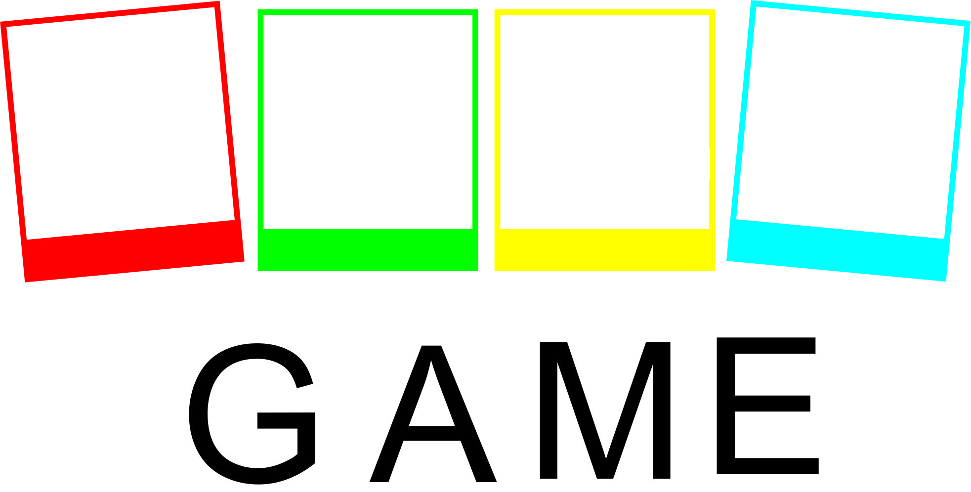


Working with a student with social, emotional and behavioural difficulties – online course

USING ONLINE GAME TO TACKLE EARLY SCHOOL LEAVING AND REDUCING BAHAVIOURAL DIFFICULTIES AMONG PUPILS
Why:
Working with a student with behavioral disorders requires not only appropriate knowledge and skills, but also experience related to practical participation in specific problem situations. The use of gamification in the process of vocational education and development is a strategy that undoubtedly influences the motivation and interest in the subject of study, making educational activities more attractive, dynamic and interactive.
What:
The GAME comprehensively presents the topic of the most frequently disturbed forms of student behavior in the school environment. The theoretical content concerning their manifestations, causes and consequences is provided with a proposal of specific corrective and simulation actions.

About:
The interactive didactic GAME consists of an introduction and 5 modules that concern working with a student who has disorders in relations with adults, relations with peers, functioning in a group, self-perception and task situations. Each of the modules covers detailed aspects of working with a student experiencing a specific type of difficulty, such as: aggression, refusing to cooperate, manipulating, isolating, focusing on oneself, impulsivity, mobbing, anti-social behavior, lack of acceptance of cultural differences, depression syndrome, different sexual orientation, provocation, self-destructive behavior, shyness, specific learning difficulties, ADHD, executive function disorders, internalizing disorders, obsessive-compulsive disorders. Particular scenarios, in addition to the theoretical part, contain elements of simulating specific events that teachers, educators or educators encounter in their daily work. Some of them contain tasks, quizzes, tests or questions summarizing individual stages of the game. By going through the modules, the player collects points, which are then added up and interpreted.
Who:
The course using the GAME didactic game is intended not only for future educators, but also teachers and educators of primary and secondary schools who want to confront and improve their previous professional experience in the field of working with children and adolescents with behavioral disorders. The interactive GAME should be of interest to all those who conduct trainings and courses on preventing early exit from the education system and/or correcting social, emotional and behavioral problems among students. Undoubtedly, it is an attractive didactic tool, which should be of interest to both vocational training institutions that conduct courses in the field of continuing education of teachers, educators or social workers, non-governmental organizations working with children and adolescents with social, emotional and behavioral disorders, as well as counseling centers. family and organizations running support groups for them and their parents. The group of recipients of a course conducted with the use of the GAME should also include local government units that want to organize and conduct free courses on working with students with social, emotional and behavioral problems, as well as effectively create social policy.
What can you find in a course?
INTRODUCTION
MODULE I: Problems in relationships with adults
1. Work with an aggressive student
2. Work with a student with no will to cooperate
3. Work with manipulative student
4. Work with an isolating student
5. Work with a student who focuses attention on himself
MODULE II: Problems in peer relationships
1. Work with impulsive student
2. Work with students with bullying behaviors
3. Work with students with anti-social behaviors
4. Work with students with difficulty to accept cultural differences
5. Work with students with difficulty to accept ideological differences
MODULE III: Problems in interactions with the group
1. Group definition, functions, types of groups
2. Teamwork skills
3. Identifying the problems in group functioning
4. Discovering the possible ways of solving the conflict
5. Styles of solving problems
MODULE IV: PROBLEMS WITH RELATIONSHIP TO ONESELF
1. Work with student with depression syndrome
2. Work with student of another sexual orientation
3. Work with provocative student
4. Work with student with self-injurious behavior
5. Work with shy student
MODULE V: PROBLEMS IN TASK SITUATIONS
2. Work with student with Executive Functions Disorders
3. Work with student with Attention Deficit Hyperactivity Disorder
4. Work with student with internalizing disorders
5. Work with student with Obsessive-Compulsive Disorder

BACKGROUND:
This course is an output of the project GAME co-financed by Erasmus + program and prepared by consortium of 6 EU countries:
The Pontifical Univeristy of John Paul II in Krakow – Poland
Stowarzyszenie ARID – Poland
New Edu – Slovakia
University of Patras – Greece
Asociatia Centrul de Training European – Romania
Amadora INOVA - Portugal

For more information see: www.projectgame.eu

